### **Introduction:**

Hi, I’m Spiros Kapetanakis. I'm just a student at Saint Paul college, blah, blah, blah, I'm more excited to talk about my final project for my intro to computer graphics course. Throughout the weeks before our final, we were introduced to a variety of computer graphics programs, (with the exceptions of garage band and indesign). Which was all building up for us to take two of the programs and master them by making 2 portfolio worthy works.

### **First Project: Adobe Photoshop**

For the first one, I decided to use Adobe Photoshop and create a family christmas card. Now, to me that sounds really basic, so to challenge myself, I made it in a way where the members of the family were Christmas ornaments on a Christmas tree. There are also three cats, which I originally wanted to also make ornaments but I found a better way to include them part way through.

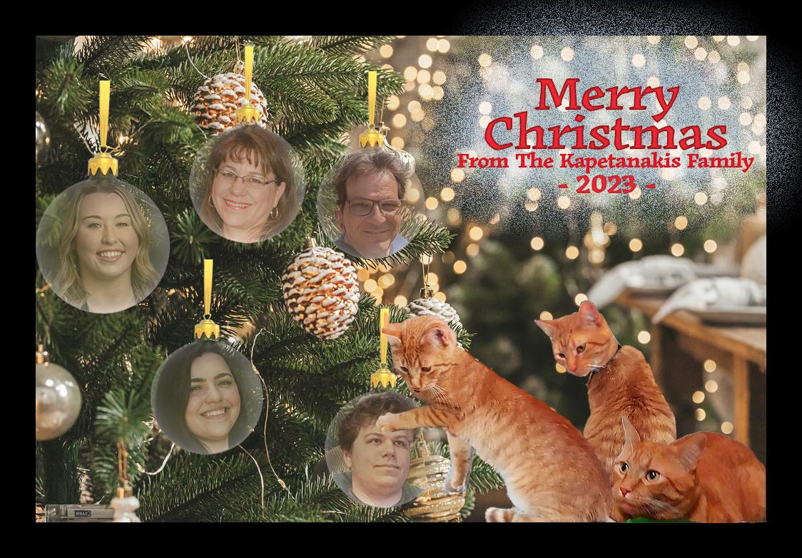Bellow is the final result (Spoilers I guess)

#### **Project 1: How it’s made:**

To start out, I needed to theory craft what I wanted to DO. I knew I wanted to do a Christmas card but that can be presented in multiple different ways. It took some time, but I eventually found a christmas card concept I liked, and decided I could do something similar.

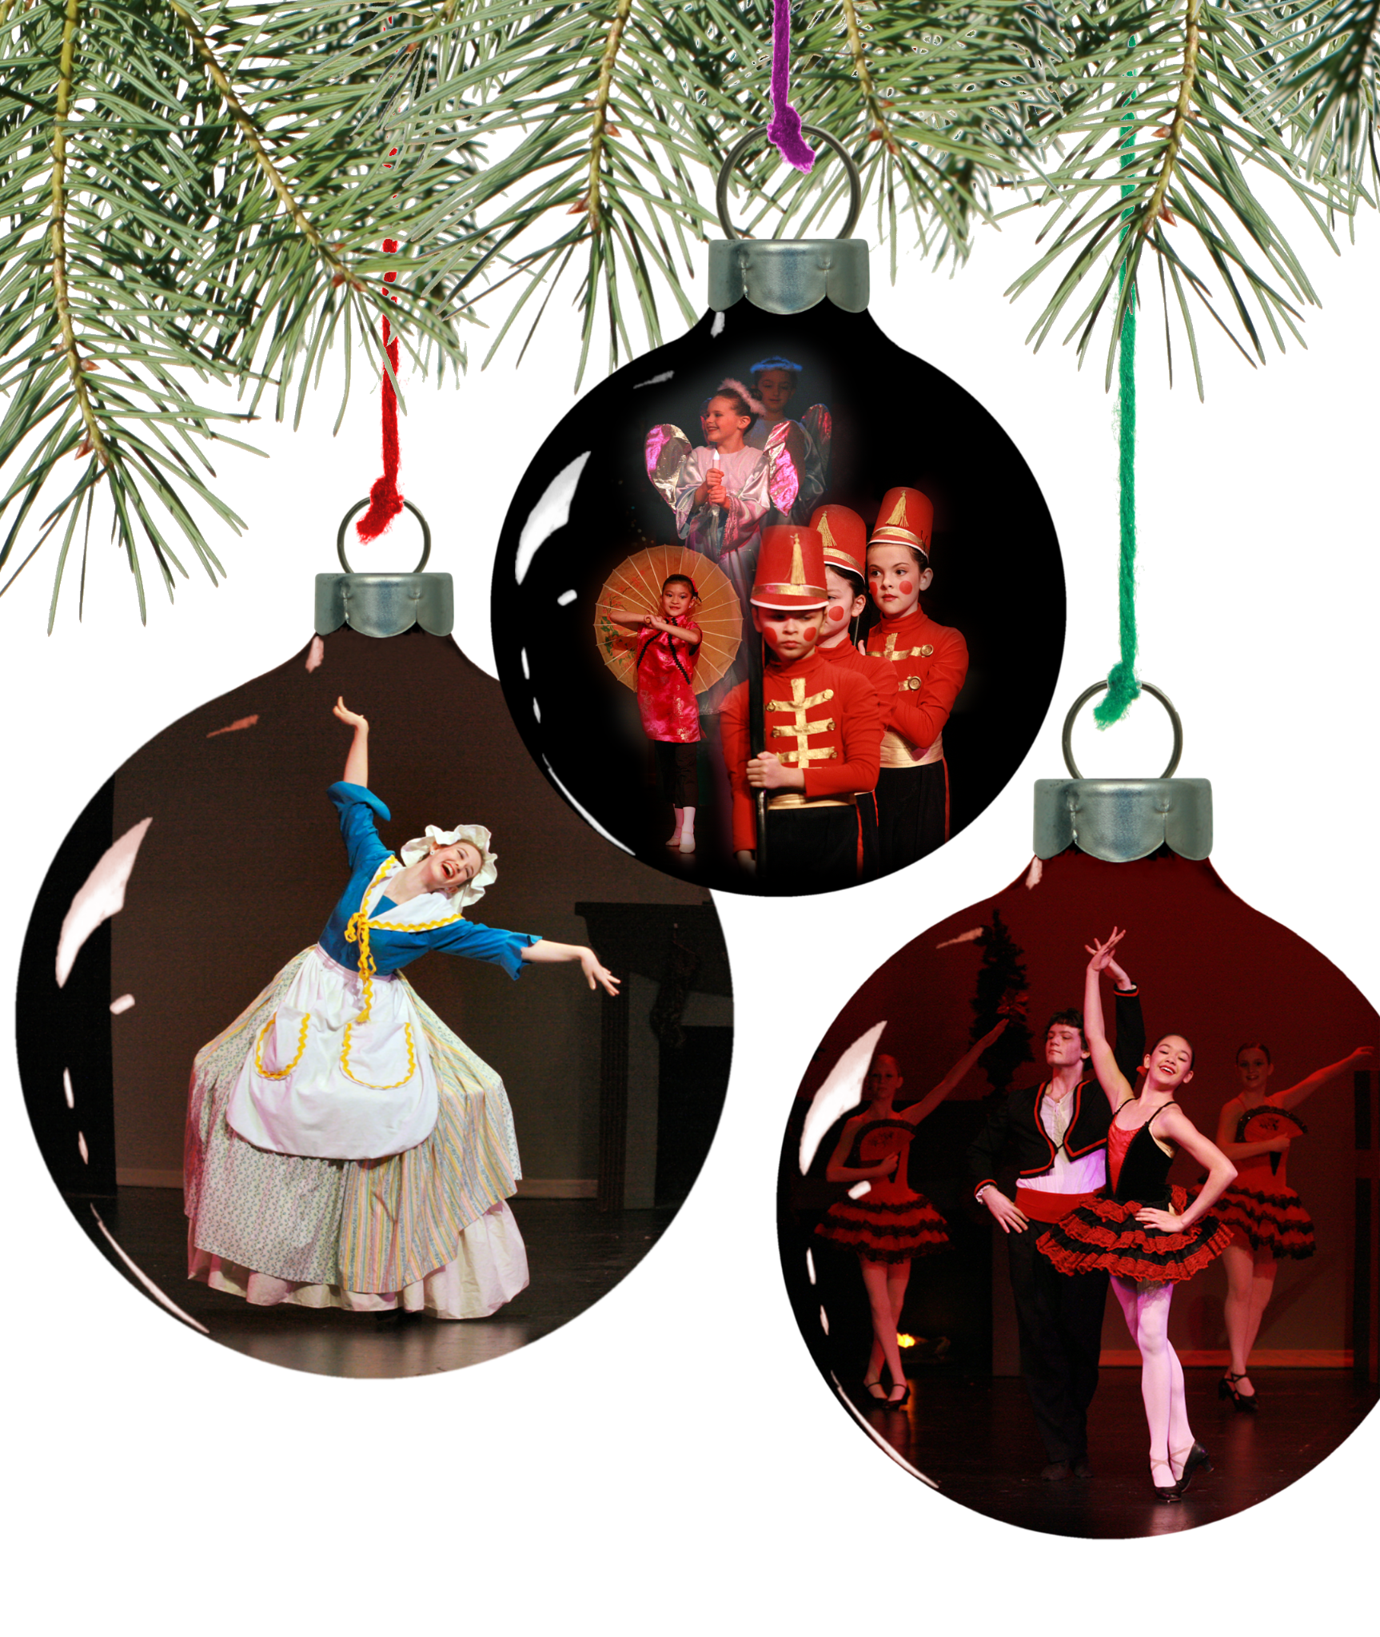

It’s not much to look at, but It does kickstart the idea of putting images inside ornaments. Since this will be our actual Christmas card we will be using, I discussed using this concept on the card.

I was wanting it to be a basic background with the ornaments hanging from the top of the image, like the example is, but I was pushed to take it a step farther and put the ornaments in a christmas tree.

It’s a great idea, I wanted to take a photo of OUR christmas tree that we had set up, after multiple angles that i was unsatisfied with I gave up and instead searched for a christmas tree on google using the creative comms filter.

This single step in the project is what took me the longest. I've gone through about 7 different tree images, i set up all the ornaments, didn’t like how it looked, and started over. The things I was mainly looking for was to have enough space for about 5 big ornaments that don’t look out of place in the image and some space on the side of the tree that I can use to put in some text. At worst, if i found a good tree image and it didn’t have space, I could just create a black background with some text on it like most christmas cards seem to do.

At long last, I settled on this tree, no matter what, this would be the one as it had that space i was looking for. What I didn't realize is that I would only have space to fit about 5 ornaments, which leaves out the 3 cats.

The next step was finding a good ornament that I could use to put on the tree. It turns out if you search for a transparent ornament on google under creative commons there's almost nothing to use. So I opted to make my own.

The starting image I went with had a crest on it, which I couldn't keep as I wanted to make it look see through. I started by using the spot heal tool to make the crest disappear. After that I copied 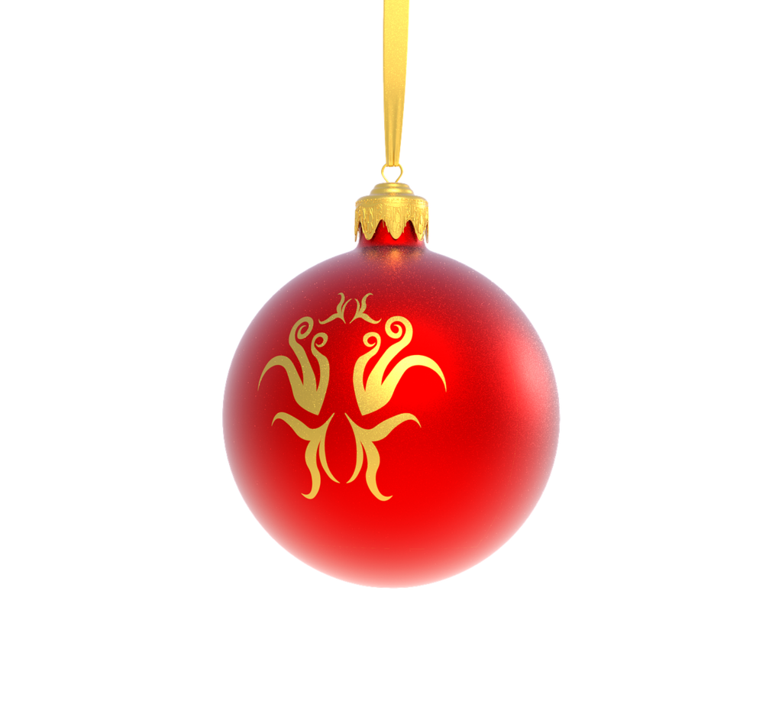the golden stem and made it a separate layer and pasted it on top of the one that's there. With the new layer on top, I put the old layer ar 45% opacity.

And to finish it off, I changed the hue to a more 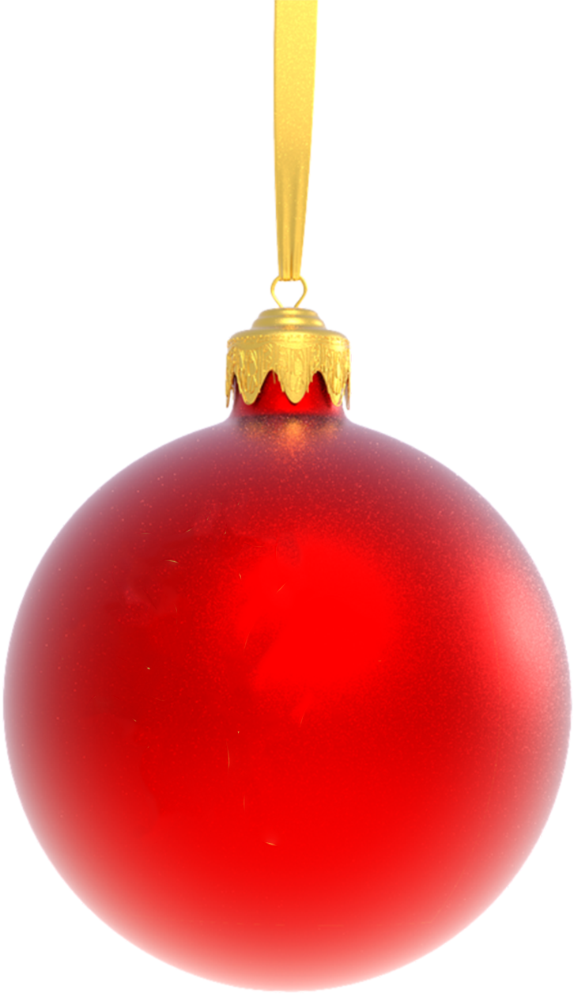yellow colored orb to better fit the lighting in the 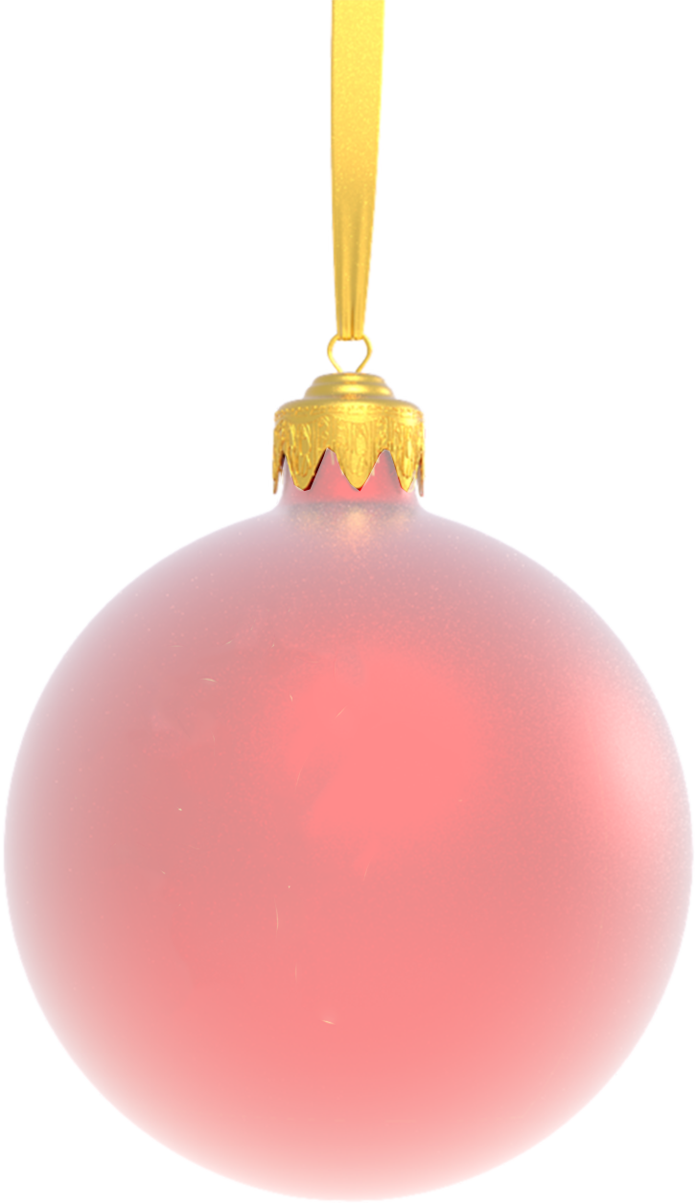image.

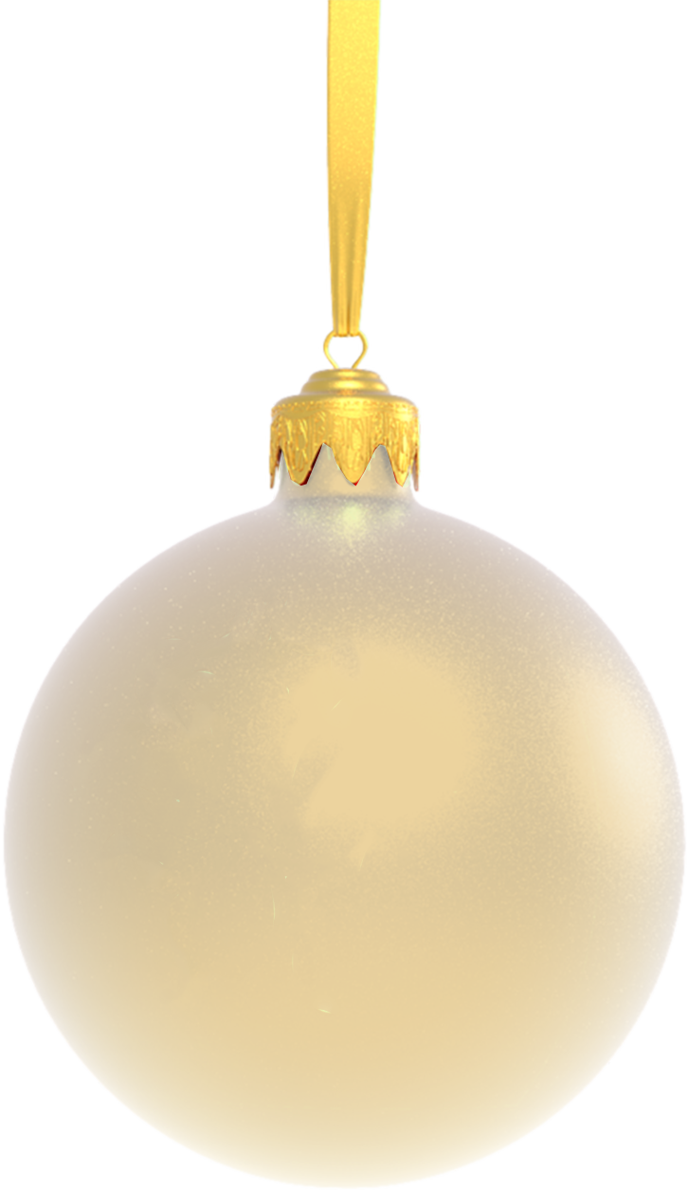

Once the orb’s were in position I moved on to the text, to create the cool snowy effect I used the ‘outer glow effect’ and made it more scattered. I then added a slight inter glow as well with a 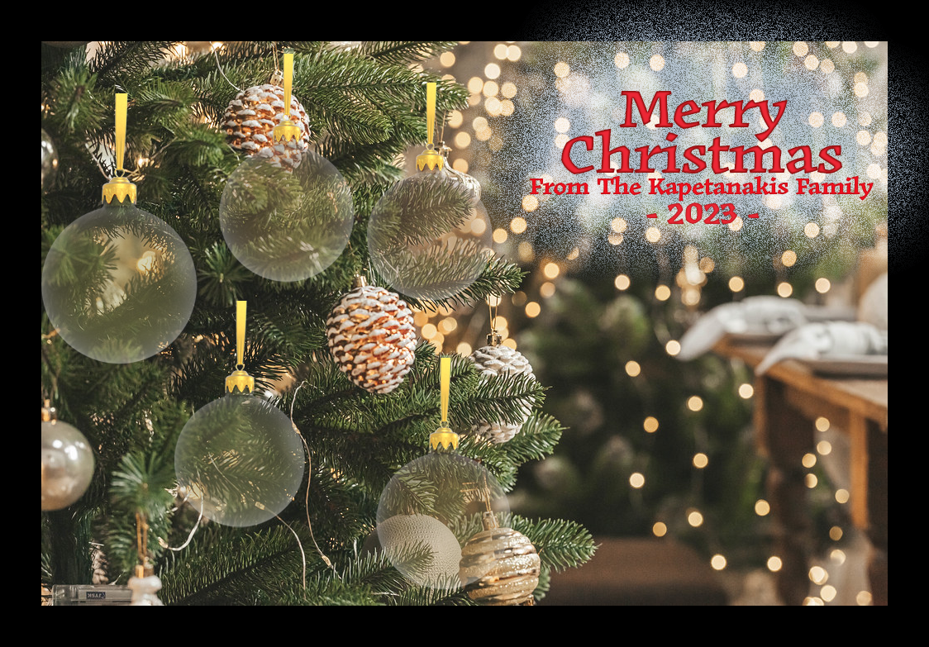darker red to make the text pop a bit more. After this i gathered up family photos and used the auto

Remove the background button. It creates a layer mask that outlines the person's figure automatically.

I converted the image into a smart layer and added the mask to the layer. I did some slight adjustment with hue and saturation to make the faces pop a bit more and have more unified lighting.

Now, we get to the interesting part. I wanted to add in our 3 cats looking up at the tree. Being cats, we have a whole cat-a-log of photos. For two of the cats, I had to find and combine two of the cat photos. To create a more dynamic pose. 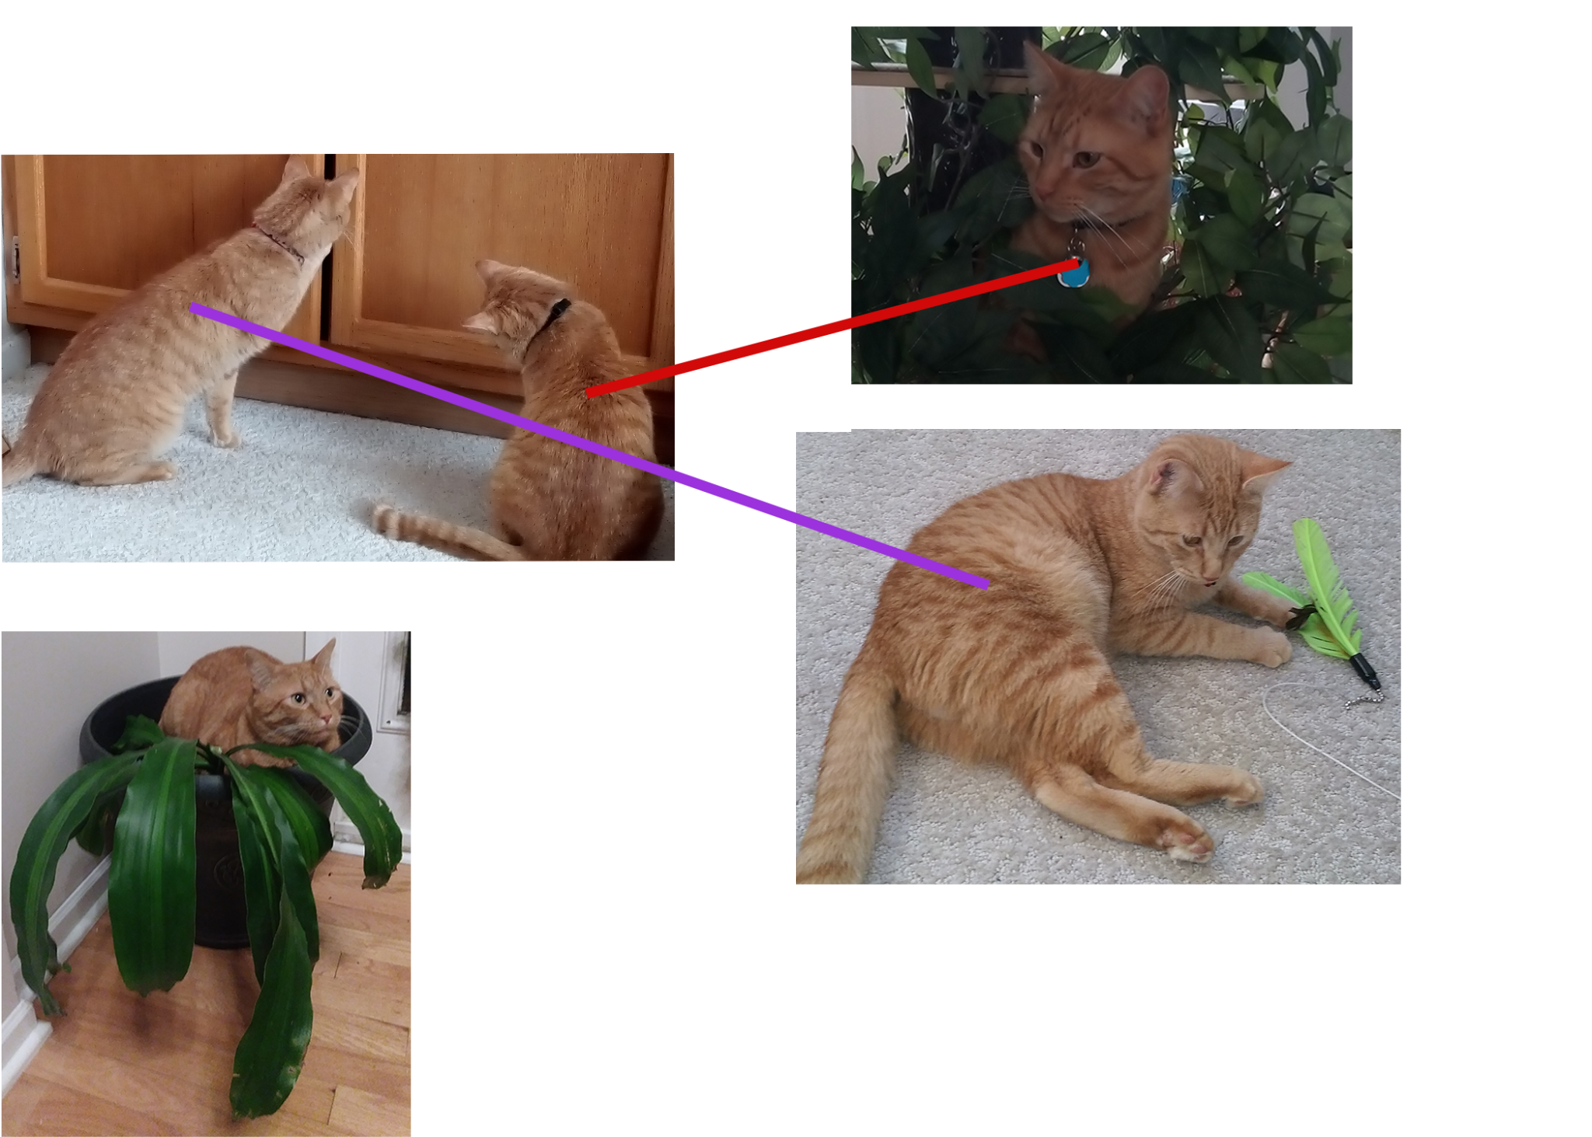

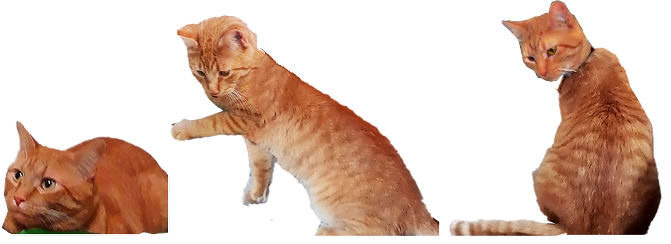

For all of the cats i changed the brightness and contrast to make the colors pop more, and the hue and saturation to unify the lighting of the two images i combined for the last two cats. Once i put them in a position i was happy with, i cut off the head of the body image and merged the layers of the two cat parts, I needed to merge the layers together so i could use the spot heal tool to seamlessly connect the two images together.

And with that, I’ve done it, the christmas card has been made in all of its glory! Now, on to the next project!

### **Second Project: Illustrator**

<https://www.youtube.com/watch?v=HFxEbh0uLHs>

For the second project, we were tasked with finding a video tutorial on how to do something within any of the software we covered in class. I chose to figure out how to make a colorful mosaic background using Adobe illustrate. It also taught me how to use image textures as a whole.

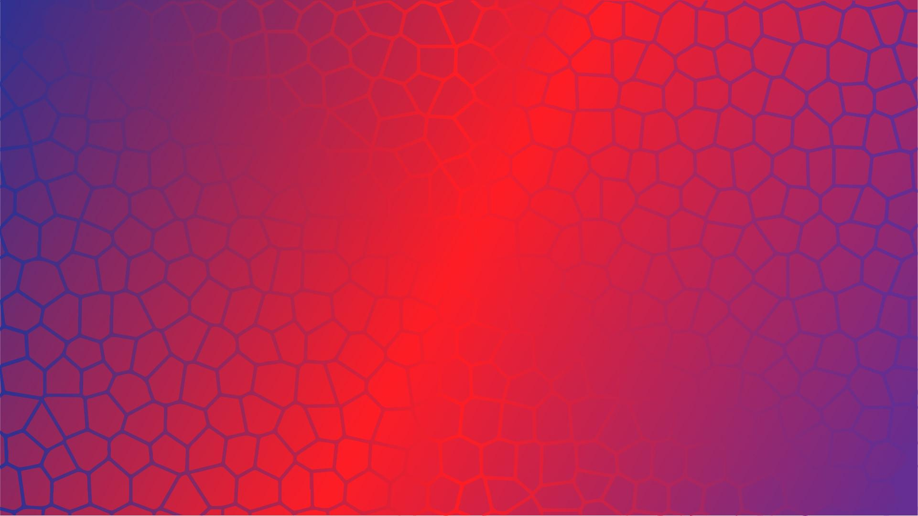

This feels too basic though, I was satisfied with the final result, and followed the tutorial as instructed but I feel like I should do another one. . . so i did.

<https://www.youtube.com/watch?v=Ps7Z1Aw_Zr0>

The second video I did was covering how to make repeating patterns and add them to the swatch board. Which I know we covered patterns in class, but this is specifically a repeating pattern, and it goes over the transform tool.

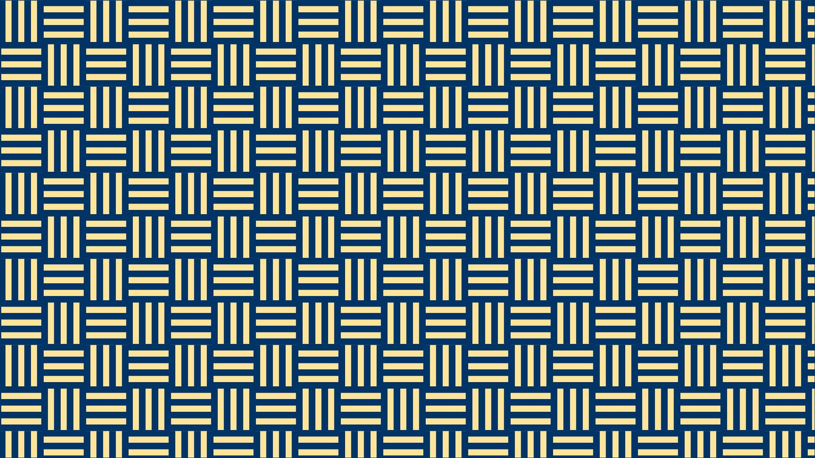

#### **Project reviews:**

##### **Project 1:**

I love the final result of the christmas card, i had an easy time with the people's photos, in the past i used to manually use the lasso tool and trace an outline of the person myself, but with there just being a ‘remove background’ button it took all that work away. The most challenging part of the whole thing was finding a good tree image that gave me the right perspective I needed. That alone took at least an hour to do. I experimented a bit with the text, I had no idea the outer glow effect could scatter like that giving it a snowy look, which was really cool.

The spot heal tool is always fun to use, I zoomed into the cat images and really obsessed over it, I would say I did a pretty good job with it for the most part. I wasn’t exactly sure how the layer masks worked at first, so I did a bit of research in the middle of making it and utilized those the best I could.

##### **Project 2:**

This still feels weird to me, that all I needed to do was follow a tutorial on how to do something, the tutorials I followed clearly showed the pathing of where the tools were and were relatively short.

I chose to follow them 1 for 1 mostly, with the mosaic pattern I also changed the path color to be a gradient too so it subtly shows creating a cool looking effect. I also played around with color theory to get some striking color combos, but I feel like I'm just patting out my word count just by saying that. I don’t really know what to put here, I followed the tutorial, i thought it was put together well and i followed them closely. Are they portfolio worthy? I wouldn’t really think so, I've made some pretty intuitive backgrounds before I feel like I'm capable of so much more than this. At least, it’s a start, this is still my first time using this program specifically and I'll only get better from here.

### **Overview of the class:**

With this being a graphics class and me being interested in the topic before the class, it’s no surprise that I enjoyed the subject that was covered. So, instead I’ll mostly cover my thoughts on how the material was presented.

Before going into the class, I had about 6 years of experience with a photoshop like web browser called [pixlr](https://pixlr.com/). It was super handy because I could sign into any computer anywhere and work on my photo edits without having to download any software. I’m a part of an online community where I serve as an event runner for competitions within the game and I lead a newslettering group called TLR (The Lab Report) where we make articles covering the most recent happenings and news about the game.

In recent times, the pixlr website has changed a bit where it now has a paid membership. It's cheap now, but if I have to pay for a program, I'd want it to be something that has more permanence than a web browser. Don’t get me wrong, I love how pixlr is presented and i think it’s impressive that something like that can run on a website with little to no issues, but seeing what the adobe line of products is capable of, pixlr doesn’t have nearly as many features.

Having all this experience of using a photo editing program made it really easy to convert and understand what the lessons were trying to teach us, even if I didn’t know anything, i’m sure I would be able to handle it pretty well, the new programs we covered all paired into each other perfectly where we usually were building off of the experience of the last program that was covered. An example of this is learning what the timeline is in adobe animate, then when we move to blender we already have knowledge of how the timeline sort of works.

I would say, to anyone taking this class, it puts a lot of trust in YOU. A lot of the work involves you using a specific tool or feature and it’s up to you to figure out how you want to use it. All of the assignments were customizable and have multiple ways to complete them. (it’s hard to restrict that in an art class but still) The class teaches you the basics and expects you to expand on that knowledge, which is a good thing and it’s done perfectly.

### **Going forward:**

When I first took this class, I had the mindset that I wanted to actually learn how to be a graphic designer as a hobby project. From what I've seen, Being skilled with digital art can be applied to almost any aspect or career of my life going forward. I wasn’t aware of how being a full time graphic designer as a job worked, and by asking questions and doing my own research, it might be something I consider doing on the side.

I will without a doubt use this knowledge for any personal projects of mine I have for the future and I’ve been sold on the adobe line of products. This class showed me why these programs are considered to be the industry standard and is something I want to dedicate more time to learning for fun.